2017 IPWDA Nationals / Conference

When: October 13 – October 19, 2017

Hosted by: Fayetteville Police Department and Cumberland County Sheriff’s Office

Where: Fayetteville NC

Hotel: Ramada Plaza
1707 Owen Dr
Fayetteville NC 28304
(910) 323- 0111

NOTE: When making reservations please state you are with the K-9 Nationals. We have been provided a special rate. They are reducing the $50 pet fee to $5.

Cost: $250 per person, must be a Current IPWDA Member (Non-members add 60.00 for regular membership and 75.00 first time Associate Member).

Deadline to register is September 15, 2017.
After September 15, 2017 registration fee goes to $300
Absolutely NO REFUNDS after September 15, 2017

Notes: At this time all certifications will be offered
Tentative Schedules are:
Saturday E Board Meeting
Saturday Accreditation Meeting (Trainer and Master Trainer Testing)
Sunday Master Trainer and Trainer meeting
Sunday Check-in, Noon
Monday – Thursday Testing and training
Thursday Banquet
Friday Check out and departure

Guests: Currently the plan is to conduct a decoy class. Training and certifications offered, but not all inclusive are; trailing, K-9 First Aid, Tactical Building Searches, K-9 Legal up-date, Booby trap, hidden compartment, and Scent theory. (These are tentative, working on the details. Updates will be forthcoming). Planning on different vendors attending!

Contact: Heather Napieralski : waddtt@aol.com
Dianne Bettis: bettiscanine@aol.com

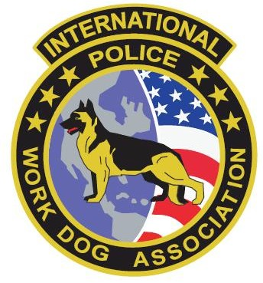
2017 IPWDA Nationals / Conference

Fayetteville North Carolina

This seminar is offered by the International Police Work Dog Association and hosted by Fayetteville Police Department and Cumberland County Sheriff’s Office.

October 13 – 19 in Fayetteville North Carolina

The seminar fee is $250 upon pre-registering for the event on or before September 15, 2017^{th.}
Thereafter, attendance fee is $300.
Absolutely NO REFUNDS after September 15, 2017.

- Narcotics Certification: Vehicle, building, area, and luggage
- Patrol Certifications: Aggression, Building and Area Search, Tracks and Trails
- Explosive Certifications: Phase I, Phase II and Phase III
- SAR Certifications: Water and land Cadaver
Human Remains and Crime Scene Testing
Wilderness and Trailing
Disaster (Working on the details now)
- Arson Certification: Accelerant
- Firearms Certification: building, area, vehicle, and lockers
- Disaster: Working on the details now on what to build.

Professional Photography at training and certification locations are taking photos throughout the seminar for attendees. Disks with conference photos will be provided for you for your wonderful and fond memories of the 2017 Nationals.

The tentative schedule is but subject to change:

Saturday: 10:00 am E board Meeting.
E board members will be the only ones to have rooms paid for on Friday night. If you come on Friday night and are not an e board member you will be responsible for your room.

Saturday: 1300 hours Master Trainer and Trainer Testing
1700 hours Master Trainer and Trainer Meeting

Sunday: 12P (Noon) check-in

Start obedience and evidence testing (obedience mandatory before training and certification attempts)

Monday: Testing and Training 08:00 until finished
Tuesday: Testing and Training 08:00 until finished
Wednesday: Testing and Training 08:00 until finished
Thursday: Testing and Training 08:00 until Noon, 1700 Banquet
Friday: Checkout and departure

Tentative classes of instruction with instructors to be announced are:

Hidden compartments
First Aid for K-9’s
Trailing
Aggression/Decoy
Legal Update for K-9’s
Booby Trap/Hidden compartment
Scent Theory

